**🡪 [[ D. FARIS,PHD :: 2013-03-25 :: ZIRK / AVS4 ]]**

**🡪 AV.Universe / AVSCreener :: LOOK-BACK BUTTON ISSUE**

🡪 In Live-Mode, LOOK-BACK button is very flaky – sometimes it shows and sometimes it does not show

🡪 Testing might show (from Garcken) when you go from Playback-Mode to Live-Mode (versus what?)

🡪 Testing today with Version 4.0.0.0 (Official VS Installation Installer):

**\*\* RELEASES (PER KALTGRAD & GARCKEN, 2013-03-25):**

-- ALPHA Released this Friday (2013-03-29) should be **“4.0.1.0”**

-- Further releases like our next BETA (2013-04-30) will be **“4.0.2.0”**

-- For now, VERSIONS should be **“4.0.0.x”**

-- Where x gets bumped at major test release cycles.

**🡪 [[ D. FARIS,PHD :: 2013-03-27 :: ZIRK / AVS4 ]]**

**🡪 AV.Universe / AVSCreener :: LOOK-BACK BUTTON ISSUE**

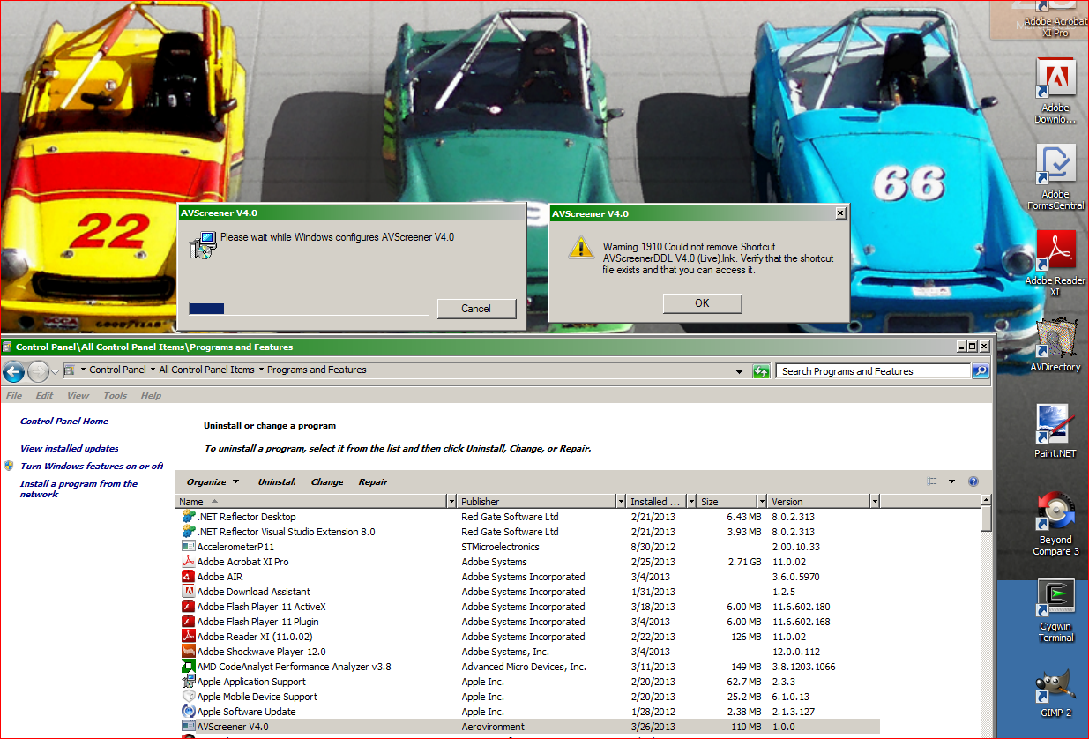

**🡪 [[ D. FARIS,PHD :: 2013-03-27 :: ZIRK / AVS4 ]]**

**🡪 AV.Universe / AVSCreener :: LOOK-BACK BUTTON ISSUE**

**🡪 THERE ARE A HUGE NUMBER OF INSTALLATION ERRORS:**

See for example, the work of Bryan Hudson at:

ALSO:

**🡪 ZIRK-AVS-V4.0 :: FAILS TO UNINSTALL DESKTOP LINKS**

**--- Start Menu, Program Files :: Gone**

**--- REMAINING --- C:\Users\Public\Desktop\ { “AVScreener-V4.0 (Live).lnk” , “AVScreener-V4.0 (Playback).lnk” }**

**--- Even the icons are messed up because the icon images are gone (from Program Files … or something)**

**--- How to force deletion on uninstall for: Desktop Shortcut *.LNK**

**🡪 VMWARE PLAYER / WORKSTATION ++ WINDOWS XP IMAGE (Chuck Baker 04/02/2013):**

**--- Start Menu, Program Files :: Gone**